

Asset Practice Answers: Science

**1. A group of students wish to measure the height of a plant. Which of these will help them measure it?**

**A.** A weighing balance

**B.** A thermometer

**C. A ruler**

**D.** A lens

**2. How old may the oldest person in the world be?**

**A.** 50 years

**B.** 80 years

**C. 110 years D.** 250 years

**3. Which of these is nearest to us?**

**A.** The sun

**B.** The moon

**C.** The moving clouds

**D. A flying crow**

**4. Which of these hands moves the FASTEST in a clock?**

**A.** The hour hand

**B.** The minute hand

**C. The second hand**

**D.** All move at the same speed

**5. Before eating food, we must wash our hands with soap and water so that .**

**A.** our hands become nice and soft

**B.** the food we eat becomes fresh and healthy

**C.** the germs present in the water are washed away

**D. the germs present on our hands are washed away**

**6. The road is marked in many ways to tell us different things. Which of the figures given below shows a**

**ZEBRA CROSSING and tells us where to cross the road?**

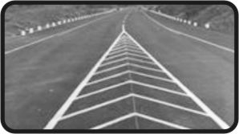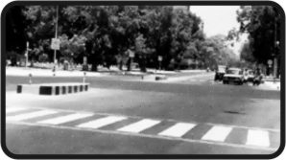**A. 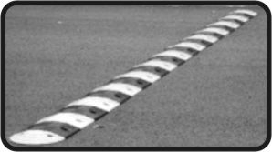 B.** 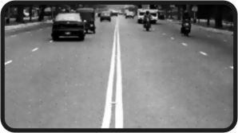

**C. D.**

**Right Answer D**

**7. In India, which of these can be seen ONLY in a Zoo?**

**A. 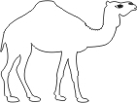 B.** 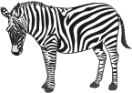

**C. 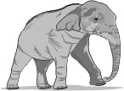 D.** 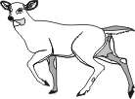

**Right Answer B**

**8. Which of these signs is MOST COMMONLY seen in front of a hospital?**

**A. 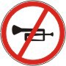 B.** 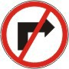

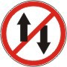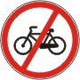

**C. D.**

**Right Answer A**

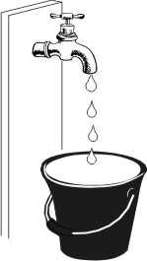**9. A tap in Vishnu's house was leaking slowly. So he kept an empty bucket under it.**

**In how much time might the bucket get completely filled? A.** 5 seconds

**B.** 1 minutes **C.** 3 minutes **D. 2 hours**

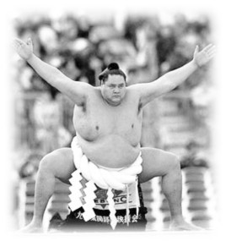**10. Shown here is a Sumo wrestler from Japan.**

**What could be his weight? A.** 50 kg

**B. 150 kg C.** 750 kg

**D.** 1000 kg

**11. Mohita has a piece of thread. She knows how long the thread is. What can she find out using ONLY THE THREAD?**

**A.** How fast her friend is walking.

**B. How far the two ends of a bench are.**

**C.** The number of spokes in her bicycle wheel.

**D.** The time it takes to reach school from home.

**12. The time shown in the clock is .**

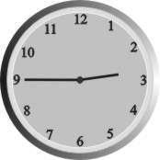

**A.** between 2 and 3 in the afternoon

**B.** between 9 and 10 in the morning

**C. between 2 and 3 in the afternoon or in the night**

**D.** between 9 and 10 in the afternoon or in the night



**Science**

1. C: The height of anything can be measured using a ruler. Though a ruler might be smaller, we can use the same ruler many times and find out the height of the plant. A weighing balance can be used to find weight and not the height.

2. C: Do you know how old your grandmother is? Do you know for how many years the oldest person in your family had lived? You should ask your parents. You will find that it will be around 100 years but not more. The oldest person in the world would be around 110 years old. It cannot be 250 years as humans do not live that long.

3. D: If you arrange the given objects from nearest to farthest, you will find that the a flying crow is nearest to us, then the moving clouds, then the moon and the farthest is the Sun.

4. C: Have you seen a clock carefully? How many hands does a clock have? There are 3 hands - the hour hand, the minute hand and the second hand. You will find that the second hand moves the fastest and the hour hand moves the slowest.

5. D: When we wash our hands, the germs and dirt that is there on our hands get washed away. Some dirt and germs may not get removed using water alone. Soap helps to remove such dirt and germs.

6. D: Do you know your road-safety rules properly? Only option D shows the picture of a zebra crossing. A zebra crossing is a part of the road that has been made for people walking on the road. People can cross the road using a zebra crossing. But you must always check for traffic before crossing the road. Options A , B and C show road-dividers, not zebra crossings.

7. B: Zebras are found only in Africa. They are not found in the jungles of India. Elephants and deer are found in the jungles of India and can be seen outside zoos. Camels are also found outside zoos. Hence, options A, C and D are incorrect.

8. A: Have you ever been to a hospital? People go to hospitals when they are ill or injured. They need proper rest to get better. They need peace around them to be able to sleep or rest properly. So, vehicles should not honk or make noise around hospitals. This is why a 'No honking!' sign is most commonly found near hospitals. Thus, option A is the correct answer. Option B shows a 'No right turn' sign, which is not commonly seen around hospitals, hence, it is incorrect.

9. D: Have you seen how long it takes for the drops from a leaking tap to fill a bucket? You can try it at home. Keep the tap slightly open so that small drops of water fall out slowly. Use a clock and find out how much time it takes to fill the bucket. You will find that it takes almost 2 hours to fill the bucket with such drops of water. 1 minute is too less and not even half the bucket can be filled in a minute.

10. B: What is your weight? What is your mother's and father's weight? The normal weight of humans is around 80 kg, but some people can go upto 500 kg or more! However, if you look at the picture of the Sumo wrestler shown, you will see that he is not very fat. Look at his arms and legs, they are not too big. His weight is closer to 150 kg than 500 or 750 kg. So, option B is the correct answer.

11. B: Mohita knows the length of the thread. So she can find out length of another object using the thread. Length of a bench means how far its two ends are. So Mohita can use the thread to find out how far the two ends of a bench are. She cannot use it alone to find out how fast her friend is walking. For that she will also require a watch.

12. C: The clock shown is a 12 hour clock. So the time shown will be seen twice in a day. The time is between 2 and 3. But it could be either in the afternoon or in the night. You may not have seen it in the night as you might be sleeping. But you might have seen 7 o'clock in the morning as well as in the evening. Similarly, even this time will be seen twice during the day.